CS 4337 Human-Computer Interaction
Bill Payment Tracker
Lourdes “Lola” Renteria
August 9, 2024

Table of Contents
Individual contributions breakdown: 2
Project description: 2
Evaluation plan: 5
Conclusion: 5
References: 6

Individual contributions breakdown:
This project was worked on by me only. I was the one to brainstorm, draft, design, and code the application. The only material referenced was in relation to Android Studio and how to code the SQLite Database.

Project description:
From brainstorming an application to design, I always thought of myself as the primary audience. For some time now, I had been thinking about what it would be like to create a simple medication tracking application. I have tried various tracking applications, from habit trackers to only medication trackers, but they all felt too overwhelming. Most of them required multiple menus to be accessed to create an entry or track a habit. Others required too much information that I did not consider relevant to the things I wanted to track. The second idea that came up during brainstorming phase was to create a bill payment tracking application. Due to my ADHD, I tend to miss payments on my bills which leads to late fees, and other times I would forget that there was a payment already pending and post a new one resulting in a double payment for the month.
The other potential users that I identified to use my application were fellow people with ADHD, and other disabilities that impact their finances. Trouble with keeping track of bills is identified in people with ADHD. I considered that they may also search for simple bill tracking applications. I wanted to create an application that was not overwhelming with multiple menus or having to click through multiple screens to save a bill.
The purpose of the application was to be a simple bill payment tracking system. Upon opening the application, the user would see a calendar with highlighted days of the month, and below a list that contains all the bills they have. This home page would make it easy for the user to see what bills they have upcoming and be able to make them on time. From the home page, they would click on the menu button in the bottom right and see a selection of menu items. The menu items would be: Add Bill, Add Payment, Delete Bill, View Payment History.
When the user clicks on the Add Bill menu item a dialog box would appear. The dialog box would say Add a bill to track as the title, with two input boxes, one input box would be Bill Name and the other would be Day of the Month with a hint to enter a number from 1 to 31. The reason for the Day of the Month to only be a number is because the bill due date does not change from month to month. It would also make it easy for the user to see what number day the bill is due at a quick glance without having to spend time clicking through the highlighted dates of the calendar to find what bill is due that highlighted day. Once the user fills out the two input boxes, then they would have the choice between two buttons, Save and Cancel. They could go ahead and save the bill information, or they could cancel and return to the home screen.
The next menu option would be Delete Bill. A different dialog box would pop up with the title Delete a bill. In the box would be a drop-down menu where the user would click on and select the bill that they want to delete from their home screen list. After selecting the bill from the drop-down menu, they would select the Delete button to proceed with deletion or the Cancel button to back out of the form.
The Add Payment menu option brings the user to another screen where a form to fill out is waiting. The form would be titled Add Payment Record. The first item would be a drop-down menu where the user would select the bill they want to add a record of payment to. Then below that box would be an input box where the user would input the date the payment had been made. Another input box below that one where the user inputs the amount of the payment. Below that would be a check box labeled Late which would allow the user to check the box to mark that the payment had been made late. And at the bottom of the screen would be a Cancel and Save button so the user can cancel and return to the home screen or save the payment record. If the user failed to make a payment for the month, they would fill out the date box, and check the Missed checkbox that is next to the Late checkbox. When the Missed checkbox is selected, the payment amount will automatically be changed to 0.00.
The View Payment History menu option also takes the user to a separate screen where a drop-down menu would appear. From the drop-down menu the user can select the name of the bill whose payment history they want to view in list form. A button labeled Close would be at the bottom of the screen which allows the user to return to the home screen. Any payments that were marked Late would be highlighted with orange, and Missed payments would be marked Red. To denote those types of payments for the colorblind, it would also show Late or Missed next to the payment record.
In the first draft of the application’s design, the View Payment History page would show a table with all the bills as rows, and the months as columns, and the intersection of the tow would denote the amount paid. However, upon realizing how much information would be on the screen and how difficult it would be for the user to follow a specific row, that version of the page was scrapped. I also created a simple icon for the application which is the image to the right. 
The images below are the drawings I made to identify the parts of the application. These three below from left to right are the home screen, the menu expanded on the home screen, and the Add Bill dialog popup.
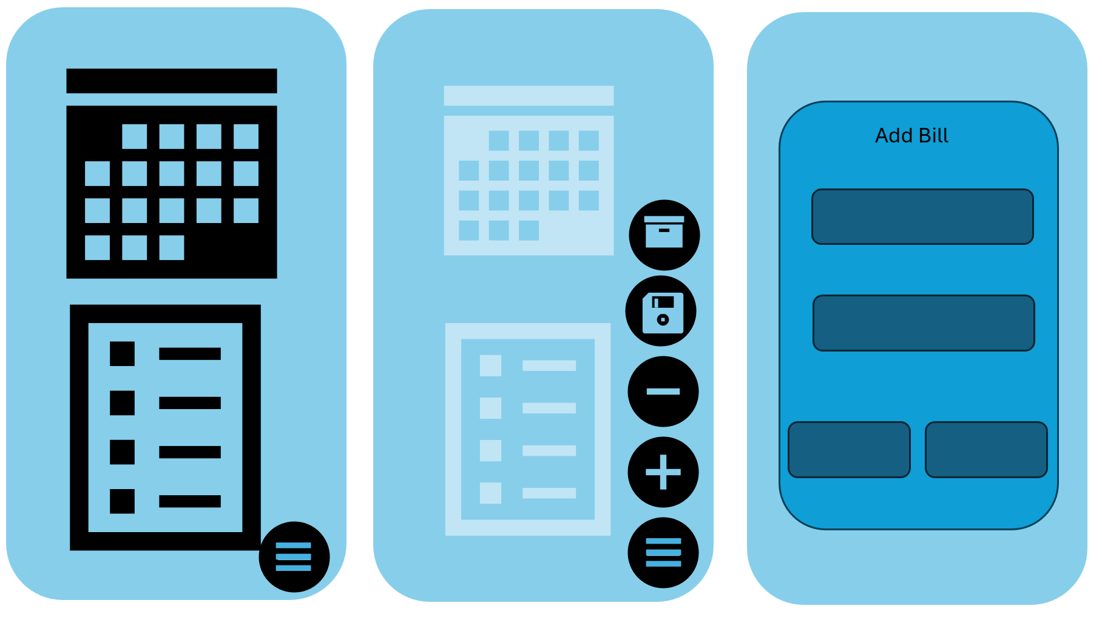
The below three images from left to right are the Delete Bill dialog, the Add Payment Record screen, and the Payment History screen mockup.
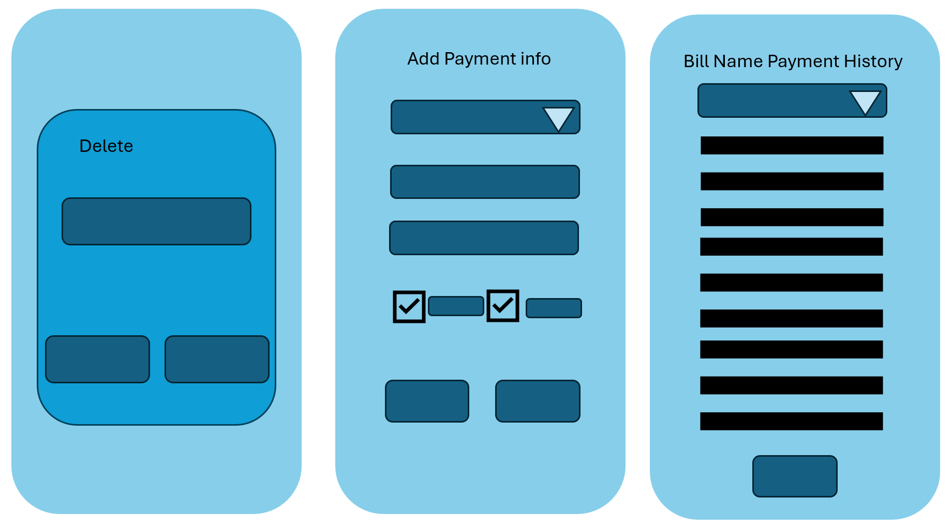
The below images are what the current application looks like. It has from left to right, the home screen, the add bill page, and the delete bill page.
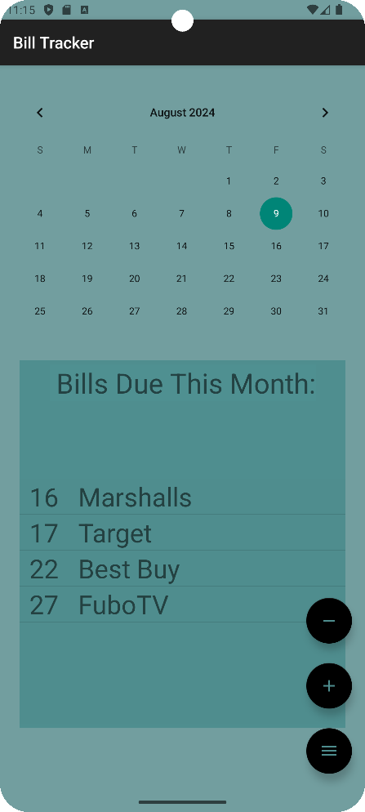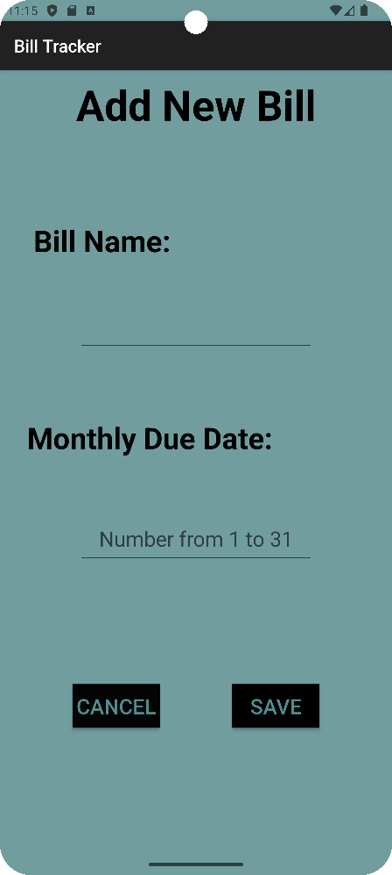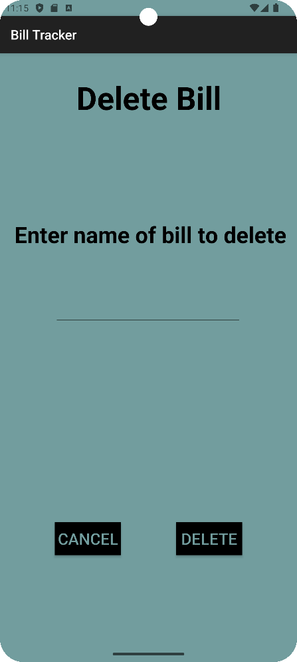

Evaluation plan:
One thing to evaluate is the amount of time it takes the application to load the SQLite database. According to the Android Studio SQLite webpage, the load time to open and close the database can be large. At the moment, the application is quick to add a bill and load the updated list on the home screen. Further testing with larger amounts of data would need to be done in order to determine if the database should be migrated to Room Database instead. Another item that needs further testing is the home page list. The list on the home screen is a ListView object that is updated every time a new bill is saved. The data from the SQLite table is loaded onto an ArrayList, which then is passed through an Adapter object to load the data onto the ListView object. According to one tutorial I found, RecyclerView objects would need to be implemented to refresh the ListView object dynamically. I believe that this is why the ListView object failed to update after running the delete bill function. Or instead, the delete function that I created is not set up correctly and needs to be modified. It would require further testing in order to determine which of the two is causing the problem.

Conclusion:
Due to time constraints, not all of the planned screens were able to be developed. The home screen was created with it showing the calendar and the list of bills below it. However, the calendar does not have the days where bills are due highlighted. The menu button was created, and it has the button to add a bill and delete a bill on it, the text that says what each icon is did not display unfortunately. The Add a Bill dialog is not a dialog, instead it sends the user to a new screen, same with the Delete Bill dialog. The database that was used to save the input data was SQLite. A table that holds the bill name and the due date is the only current table in the database. The function to add a bill to the table works, and the list view is auto populated after adding a bill. However, the list does not auto populate after deleting a bill, so I am unsure which of the two functions has the error.
Considering this was the first time I was working with Android Studio I am pretty proud that I managed to get the base of the application created and running. The SQLite database was not the most difficult thing to understand. I had tried at first using the Room Database to create the database that would hold the data. Unfortunately, I could never get that application to run, and I was unable to figure out what was causing the issue. I did encounter issues with the code and Android Studio because the code I was using needed a higher version of Java as listed on the Gradle module. I had to update the Java version and API to 17 to get some of the code to work. I would like to continue working on the application to implement all of the planned activities. I would also like to work on the color scheme of the application to be more cohesive.

References:
“Android Sqlite Database Example Tutorial.” DigitalOcean, www.digitalocean.com/community/tutorials/android-sqlite-database-example-tutorial. Accessed 9 Aug. 2024.
“Android Studio Tutorial.” GeeksforGeeks, GeeksforGeeks, 15 June 2024, www.geeksforgeeks.org/android-studio-tutorial/?ref=shm
Bhattacharya, Sandip. Populate ListView from SQLite Database in Android Studio | YouTube, YouTube, www.youtube.com/watch?v=VQEmj7Zos6Y.
“Save Data Using Sqlite : Android Developers.” Android Developers, www.developer.android.com/training/data-storage/sqlite
“SQLiteDatabase : Android Developers.” Android Developers, www.developer.android.com/reference/android/database/sqlite/SQLiteDatabase.html#query%28boolean,%20java.lang.String,%20java.lang.String%5B%5D,%20java.lang.String,%20java.lang.String%5B%5D,%20java.lang.String,%20java.lang.String,%20java.lang.String,%20java.lang.String%29
“Using an Arrayadapter with ListViewEdit PagePage History.” Using an ArrayAdapter with ListView | CodePath Android Cliffnotes, www.guides.codepath.com/android/Using-an-ArrayAdapter-with-ListView.

